Thread / Event List Page
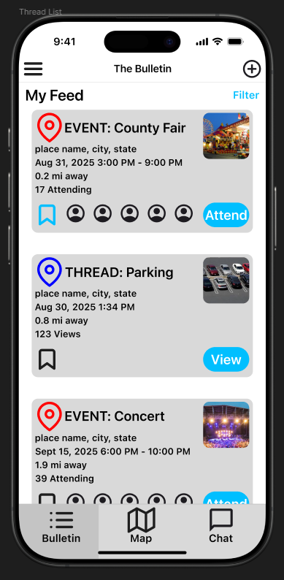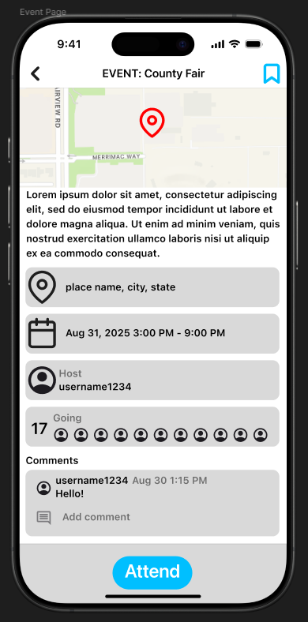

Events Page

Color Palette
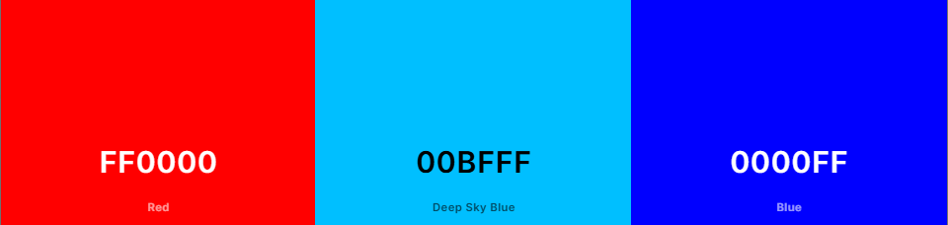
I struggled with picking out colors for my page designs. I tried looking at other social apps I use, but it didn't help much since they all use light/dark mode, which are all basically different shades of black and white. So, I ended up just picking the same colors we already had on our current Figma design.

Figma link: https://www.figma.com/design/xvuKf91xvPZUErGt7l68ap/Thread-Page---List?node-id=0-1&t=iaTEAscxgFMBIOdl-1

